No to text conversion:
#include<stdio.h>
#include<conio.h>
#define p printf
#define b break
#define c case
void main()
{
long m,n,rev=0; int r;
clrscr();
p("Enter n value "); scanf("%ld",&n);
if(n<0)p("-",n=-n);
m=n;
while(n!=0){r=n%10; rev=rev*10+r; n/=10;} /* rev */ do
{
switch(rev%10)
{
c 0: p("Zero");b;
c 1: p("One");b;
c 2: p("Two");b;
c 3: p("Three");b;
c 4: p("Four");b;
c 5: p("Five");b;
c 6: p("Six");b;
c 7: p("Seven");b;
c 8: p("Eight");b;
c 9: p("Nine");
}
p(" ");rev/=10;}while(rev!=0);
while(m!=0&&m%10==0)p("Zero ",m/=10); getch();
}
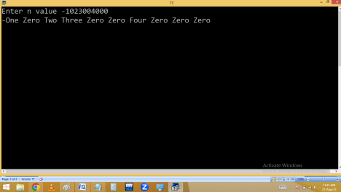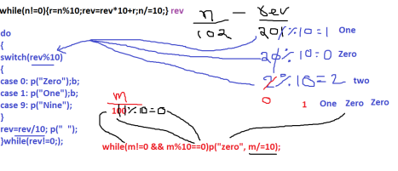Finding gcd / hcf of given two numbers.
4 divisible with 1, 2, 4
6 divisible with 1, 2, 3 ,6
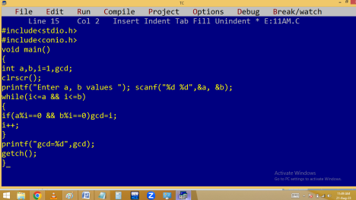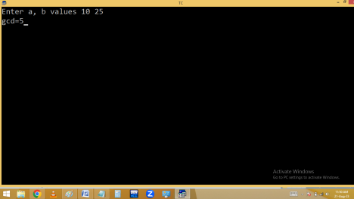
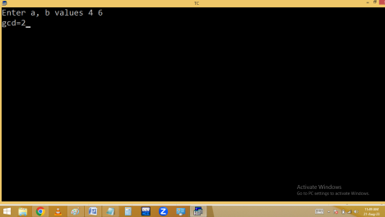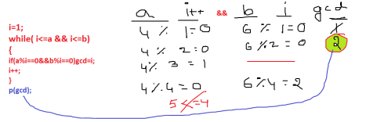Finding LCM of given two numbers.
Using gcd:
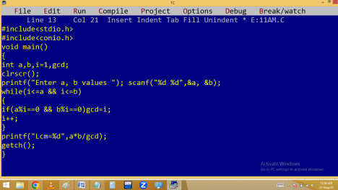
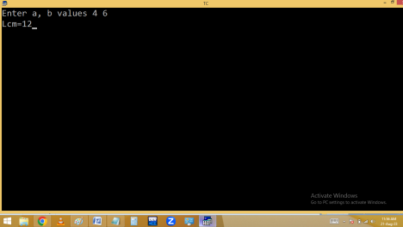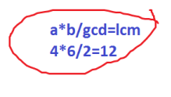
Without using gcd:
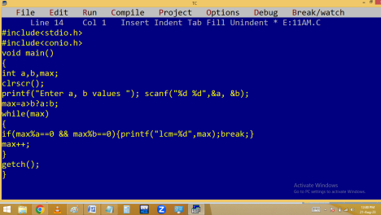
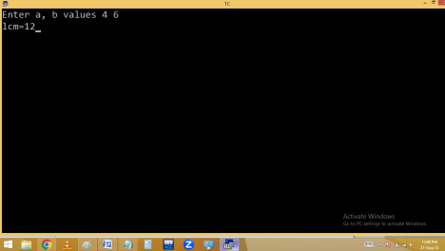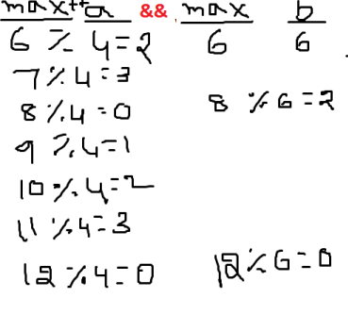
Finding no of even, odd, 0 digits in given no.
Eg: 1023 🡺 1 even, 2 odd, 1 zero
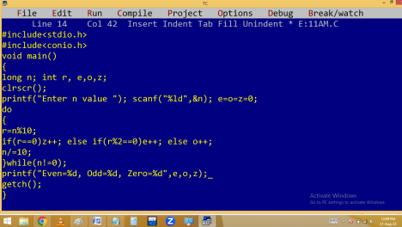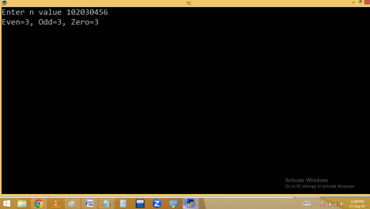
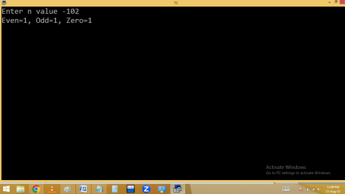
for loop:
It is an entry control loop.
for is a keyword.
It is also used to repeat a program several times based on a condition.
When compared with while and do while, for loop is looking to be smart. In for it is compulsory to maintain two semicolons. For works without condition also and default condition is always 1 i.e. true.
Generally for loop is having 3 expressions.
1. Initialization
2. Test condition / expression
3. Increment/decrement / updation
At first entry of for loop the initialization part is executed and later the test condition is checked. If the condition is true then the for block statements are executed. After completion of the block, the increment or decrement part is executed. Later once again the test condition is evaluated. If it is true then once again for block statements are executed. Like this the process is continued until the condition becomes false. Here the initialization part is executed only once, at the time of loop beginning.
It is mandatory to maintain 2 semicolon ( ; ) in a for loop.
If the for loop is having more than three expressions, it is mandatory to separate the expressions with , separator.
If the for loop is having less than three expressions, then leave the expressions with empty semicolon.
Printing given table.
Eg: 9th table
9*1=9
9*2=18
9*3=27
9*10=90
Finding perfect no.
6 factors 1 + 2 + 3 = 6
28 factors 1 + 2 + 4 + 7 + 14 = 28
4 factors sum is 1+2=3 🡸 not a perfect no Sum of factors excluding itself is equal to given no

